KANISHK BEHL

102105058

3EIC-2

Write a menu driven program with 4 options (Push, Pop, Display, and Exit) to demonstrate the working of stacks using arrays.

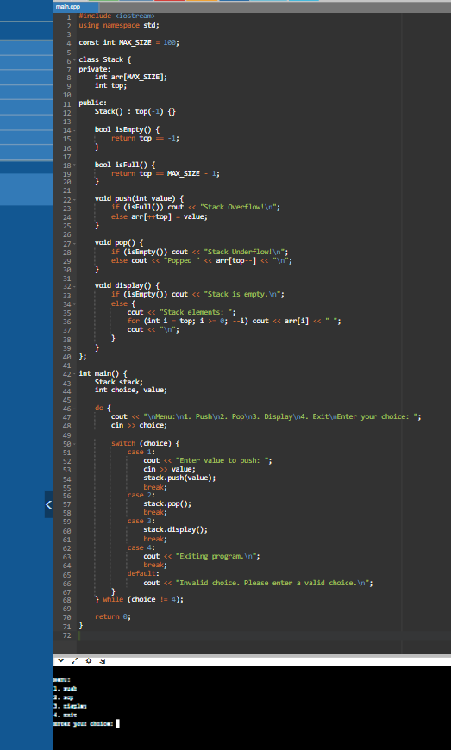

Write a menu driven program with 4 options (Push, Pop, Display, and Exit) to demonstrate the working of stacks using linked-list

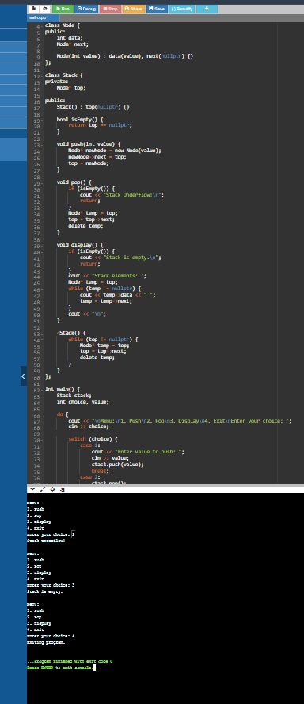

3.Write a program to convert infix expression into postfix expression using stack

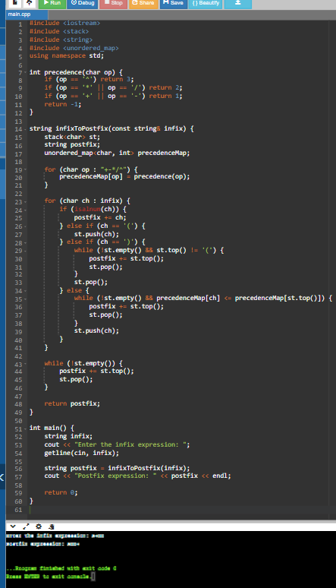

Write a program to convert infix expression into prefix expression using stack.

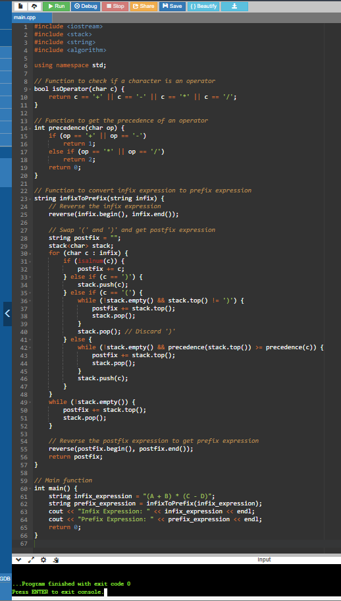

Write a program to evaluate a postfix expression using stack

